ROPER iNDUSTRiES
[EST. 1919]

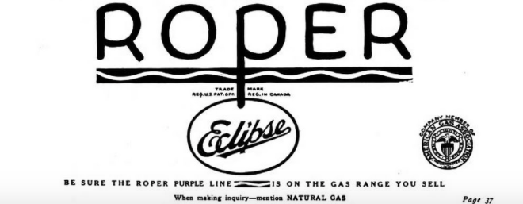

1964 NEWARK, OHiO SEARS SUBSiDiARY reaches deal
with roper
Feb 16, 1968 Labor Management Relations Act
Union Bargaining Dispute
No Merger Necessary [CBA]
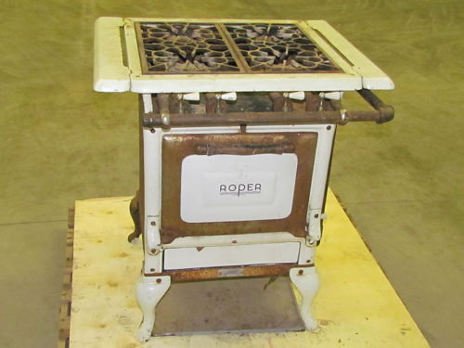
Free Flow of Commerce

June 1982 Derrick N. Key [former Johnson &Johnson consultant]
announced as Vice President
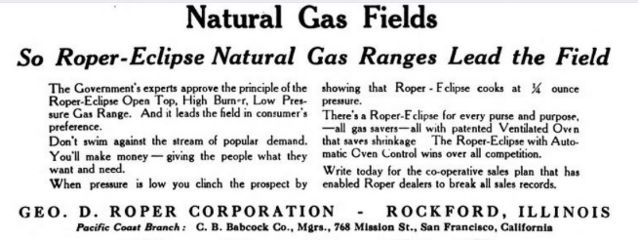

June 1985 Leveraged Buyout (LBO)
Key becomes President
*Quadruples sales
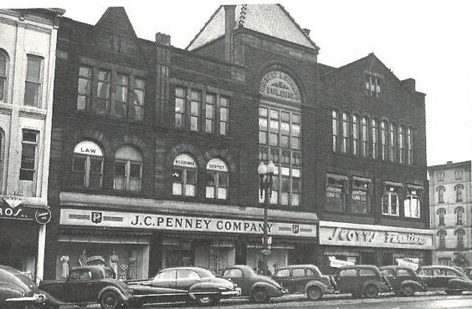
July 1990 Key acquires U..K. + Switzerland subsidiaries to obtain products such as:
Valves, Switches, Sensors

Client Name: A.M.O.T. Oil and Gas
Power Generation

Based in: Bury St. Edmunds (U..K.)
Richmond, CA
1991 Key named CEO

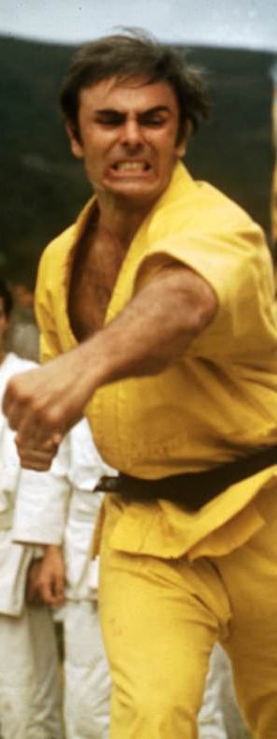

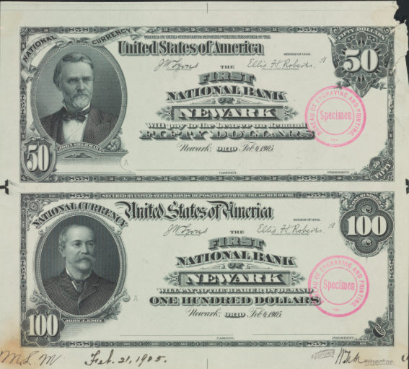

Sept. 1992 Roper Acquires
Leading Turbocompressor through

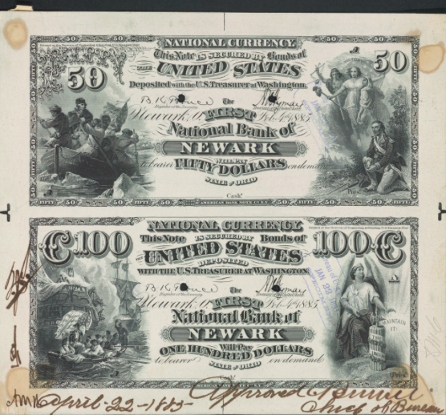
Russian merger with Gazprom

Shares climb 73%

